QUIZ- 2 Part- 2 Chapter- 8-9-10

1. One complication that tends to prolong recessionary gaps is that wages

a. tend to rise rapidly.

b. tend to move in the opposite direction from prices.

c. rarely fall.

d. are fixed by unions, which represent nearly all workers in the United States.

2. In calculating the nation's total output, net exports

a. represent exports of goods and services minus imports of goods and services.

b. have been a negative number in the last several years.

c. would include purchases of U.S.-made automobiles by foreigners minus purchase of foreign-made automobiles by U.S. residents.

d. All of the above are correct.

3. Assume that the MPC is 0.85 and investment spending rises by $100 million. How much consumption spending will this generate in the second round of spending?

a. $15 million

b. $100 million

c. $118 million

d. $185 million

e. $85 million

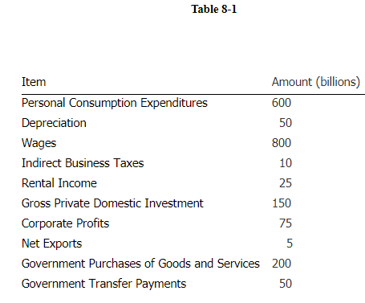

4. According to the data in Table 8-1, the value of GNP is

a. 900.

b. 960.

c. 950.

d. 955.

5. An economic boom that creates an inflationary gap is usually followed later by

a. an increase of potential GDP.

b. an increase in aggregate supply.

c. a period of stagflation.

d. falling prices.

6. An economic boom that creates an inflationary gap is usually followed later by

a. an increase of potential GDP.

b. an increase in aggregate supply.

c. a period of stagflation.

d. falling prices.

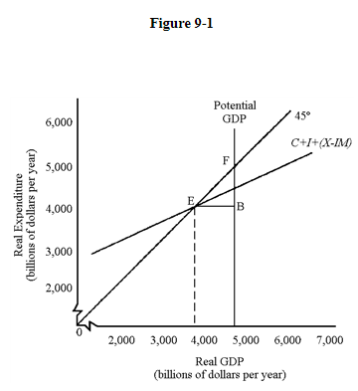

7. In Figure 9-1, the economy is

a. experiencing a recessionary gap, shown by the distance between EF.

b. experiencing a recessionary gap, shown by the horizontal distance EB.

c. experiencing an inflationary gap, shown by the horizontal distance EB.

d. at full employment without inflation.

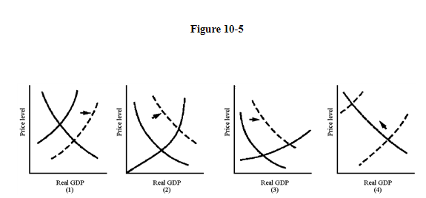

8. In Figure 10-5, which graph best illustrates the situation of an economy with high unemployment that experiences an increase in investment spending?

a. (2)

b. (1)

c. (3)

d. (4)

9. The concept that increases in spending cause larger increases in equilibrium GDP is known as the

a. multiplier.

b. mystifier.

c. depreciator.

d. profiler.

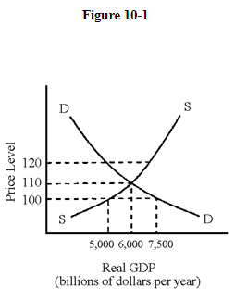

10. If the price level in Figure 10-1 were 110,

a. firms would have to lower their prices.

b. shortages of goods would exist.

c. inventories would be accumulating.

d. aggregate quantity demanded would equal aggregate quantity supplied.

11. Which of the following methods could be used to calculate GDP?

a. the sum of all spending on final goods and services

b. the sum of all values added at each stage of production

c. All of the above could be used.

d. the sum of all factor payments plus depreciation and indirect business taxes

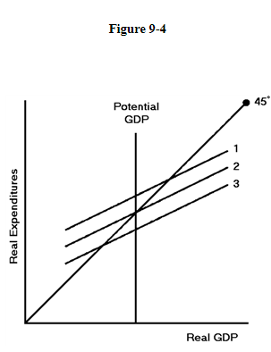

12. In Figure 9-4, which expenditure level will cause an inflationary gap?

a. 1

b. 2

c. There will be no inflationary gap.

d. 3

13. If the MPC is .80, then a change in disposable income of $60 billion will lead to an initial change in consumption of

a. $30 billion.

b. $60 billion.

c. $48 billion.

d. $70 billion.

e. $42 billion.

14. A decrease in autonomous consumption would have the same effect on the expenditures schedule as a(n)

a. increase in government purchases.

b. increase in net exports.

c. decrease in investment.

d. decrease in taxes

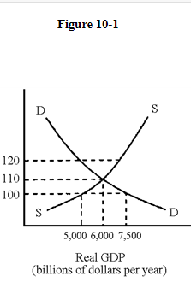

15. If the price level in Figure 10-1 were 100,

a. shortages of goods would exist.

b. firms would have to lower their prices.

c. inventories would be accumulating.

d. both c and d would occur.

e. aggregate quantity demanded would exceed aggregate quantity supplied.

16. The national income accounts include a value for the amount of capital stock "used up" during the production of current output. This dollar amount is called

a. depreciation.

b. amortization.

c. dollarization.

d. appreciation.

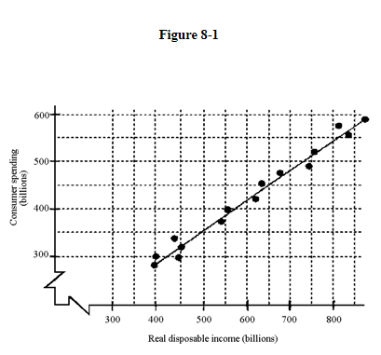

17. Given the scatter diagram in Figure 8-1, how much will consumption decrease if the price level rises by 5 percent?

a. cannot be determined

b. $200 billion

c. $50 billion

d. $100 billion

18. Using the standard 45-degree line diagram, how does a decrease in investment spending effect the expenditure schedule?

a. It increases the slope of the expenditure schedule.

b. It shifts the expenditure schedule downward.

c. It shifts the expenditure schedule upward.

d. It decreases the slope of the expenditure schedule.

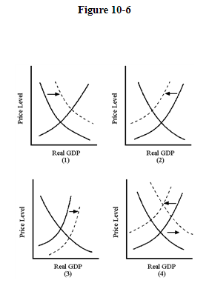

19. In Figure 10-6, which graph best illustrates the effect of the beginning of the Iraq war in 2003?

a. (3)

b. (4)

c. (1)

d. (2)

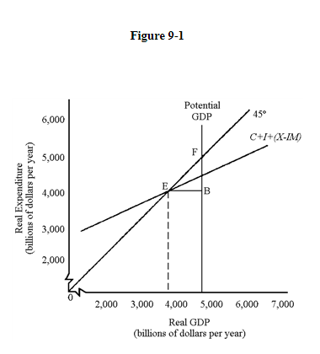

20. In Figure 9-1,

a. to the left of equilibrium GDP, inventories will fall.

b. the 45-degree line represents all points where spending equals output.

c. All of the above are correct.

d. to the right of equilibrium GDP, inventories will rise.